
Faculty of Science, Engineering, and Technology
COS30017 Software Development for Mobile Devices
Individual Assignment: Assignment 2: Rent a Car with Intents
Student's Name: Nguyen Hoang Minh - 105710964
DriveEase: a car rental app built with Kotlin, Jetpack Compose and Android Intents
Student name | Nguyen Hoang Minh
Student ID | 105710964
Tutor | Pham Dang Khoa
Submission date | November 2026
GitHub repository | https://github.com/nguyenhoangminh25251006/COS30017-Software-Development-for-Mobile-Devices (Assignment 2 code is in the ASM 2 folder)
Figma | https://www.figma.com/design/54FhaO2u7iPpxt5mYDEJw6/Untitled?node-id=1-2&p=f&t=0Td45SNyTUCpB5dD-0
Contents
1 Introduction 2
2 Planning and Development Process 3
3 User Stories and Use Cases 9
4 UI/UX Design 11
5 System Architecture and Implementation 22
6 Functionality and Technical Implementation 27
7 Testing and Debugging 31
8 Challenges, Explorations and Takeaways 35
9 Conclusion 38
10 References 38
Appendices 39
List of figures
Figure 1 GitHub commit history for Assignment 2
Figure 2 Low-fidelity sketches of two catalogue layouts
Figure 3 CatalogueScreen in light mode, with annotated regions
Figure 4 CatalogueScreen in dark mode
Figure 5 Search and sort results
Figure 6 Favourites row, including a rented favourite
Figure 7 RentalScreen with slider and live total cost
Figure 8 Validation error banners (400 credit cap and insufficient balance)
Figure 9 Vietnamese localisation on both screens
Figure 10 CatalogueScreen in landscape: side-by-side header and dashboard
Figure 11 RentalScreen in landscape with a two-column layout
Figure 12 Layered architecture of DriveEase
Figure 13 Navigation flow between the two activities
Figure 14 Booking successful toast and "Active Rentals" section
Figure 15 Booking cancelled toast and car returned toast
Figure 16 Unit test results in the Gradle test report

1 Introduction

1.1 Project overview
DriveEase is an Android car rental app. A user browses five vehicles, compares their key details, saves favourites and rents a car using an in-app credit balance. The app is written in Kotlin with Jetpack Compose and Material Design 3, and it is split into two activities that talk to each other through explicit Intents: MainActivity (the catalogue) and RentalActivity (the booking form).
The selected Car is sent to RentalActivity as a Parcelable extra, and the booking result is returned with the Activity Result API. Vehicle, credit and favourite data live in memory in Kotlin StateFlow streams, so nothing is written to a database.
The app had four goals: a clean browsing experience on a phone, rentals that respect strict credit rules, quick ways to find a car (search, sort, favourites), and a design that works in light and dark mode. Business rules are kept out of the UI and covered by 27 unit tests.

1.2 Link to the unit learning outcomes
Outcome | How the project addresses it
ULO1 Mobile versus desktop/web development | Activity lifecycle and Intent-based navigation instead of page requests; Parcelable for passing objects between components; state held in a ViewModel so it survives configuration changes such as rotation; a runtime locale switch that does not restart the Activity.
ULO2 Designing within hardware limits | Horizontal swipe cards and large touch targets for one-handed use on a small screen; lazily composed lists (LazyRow) that only build visible items; true black dark theme that saves power on OLED screens; minimum SDK 24 to cover older devices.
ULO3 Build, test and debug with the standard toolkit | Android Studio, Gradle, Compose, Material 3 components, JUnit unit tests, Compose UI tests and a debugging log of five defects with root causes (Section 7.4).

1.3 Scope and limitations
DriveEase is a proof of concept, not a commercial platform. The limits below are deliberate and were chosen to keep the focus on Intents, Parcelable and state handling.
- Five predefined vehicles: Toyota Camry, Tesla Model 3, Hyundai Tucson, BMW 3 Series and Honda Civic.
- Every user starts with 500 credits, and a single rental may not cost more than 400 credits.
- Rental length is 1 to 7 days, and pickup is assumed to be immediate.
- All data is kept in memory and is lost when the app is closed. There is no backend and no real payment.
- The interface is available in English and Vietnamese.

2 Planning and Development Process

2.1 Development plan
I read the assignment requirements first and split them into ten phases. The order was chosen so that the logic with the most risk (validation and state) was built and tested before the screens that depend on it. Screens came second, and visual refinement came last.
Phase | Task | Expected outcome
1 | Analyse requirements, check Gradle configuration | Feature list, constraints and SDK setup confirmed
2 | Car data model with Parcelable | Vehicle attributes and Intent serialisation
3 | Domain logic (CarRentalDomain) | Pure, testable validation, search and sort rules
4 | In-memory repository (CarRentalRepository) | StateFlow-based state for credits, bookings and favourites
5 | ViewModel (CarRentalViewModel) | UI state separated from repository logic
6 | MainActivity and CatalogueScreen | Browsing, search, sort, favourites, launching the rental screen
7 | RentalActivity and RentalScreen | Slider, credit validation, booking result
8 | Dark mode and Vietnamese localisation | Two themes, two languages
9 | Automated tests (27 cases) | Business rules and boundaries verified
10 | UI refinement and final review | Swipeable cards, monochrome theme, final polish

2.2 Development environment
Component | Technology
IDE | Android Studio (Meerkat / Narwhal)
Language | Kotlin 2.2.10
SDK levels | Minimum API 24 (Android 7.0), target and compile API 37
UI framework | Jetpack Compose with Material Design 3
Build system | Gradle with Kotlin DSL (build.gradle.kts)
Test device | Pixel 9 emulator (Android 15); API 24 emulator for backwards compatibility
Version control | Git and GitHub Classroom

2.3 Development timeline
Development began on 12 October 2026 and continued until the final commit on 8 November 2026. Git only records the days on which work was pushed, so the timeline below reconstructs the actual build order and estimated hours. About 82 hours were spent in total, including design, implementation, testing, report preparation, the rotation work and the final review.
Date | Work stage | Time | Outcome
12-13 Oct | Analysis and planning: requirements, feature list, Gradle setup and project scaffold | 4 h | Scope fixed; project builds
14-16 Oct | Data model: Car (Parcelable), RentalBooking, SortOption and domain rules | 8 h | Model and pure validation, search and sort functions complete
17-18 Oct | State layer: CarRentalRepository and CarRentalViewModel with StateFlow | 6 h | Reactive in-memory state layer
19-20 Oct | Interface build: MainActivity, CatalogueScreen, RentalActivity and RentalScreen | 10 h | Two-screen app with Intent navigation
20 Oct | Testing: 22 unit tests and Compose UI instrumentation tests | 4 h | Core rules covered; UI tests in place
20 Oct | Documentation: report outline, test plan, implementation plan and GenAI disclosure | 2 h | Report and test plan scaffolded
20 Oct | First visual pass: high-resolution images, layout overhaul and Next navigation fix | 4 h | Improved catalogue; navigation bug fixed
21-24 Oct | Review and refactor: code clean-up and post-build fixes | 3 h | Simpler code and cleaner repository
25 Oct-1 Nov | Design exploration: Figma screens for the monochrome direction | 6 h | Figma reference ready to implement
2 Nov | Visual redesign: monochrome theme and true black dark mode | 5 h | New look on both screens; OLED theme
2 Nov | Interaction: back navigation, specification panel, Popular Cars row and list reset | 6 h | Swipeable cards with stable selection
3-5 Nov | Localisation and controls: Vietnamese strings, locale provider and ViewModel tests | 6 h | Bilingual UI; four ViewModel tests
6 Nov | Final UI pass: buttons, controls and submission build | 2 h | Stable build before rotation work
7 Nov | Landscape support: adaptive two-column layouts and state persistence | 8 h | Side-by-side layouts; state survives rotation
7 Nov | Rotation control: full-sensor orientation, one-tap rotate button and final checks | 2 h | Rotation works both ways; final build
7 Nov | Navigation review: removed the rotate button and the arrows and Back/Next buttons; swipe and counter kept | 1 h | Simpler catalogue screen
8 Nov | Final review: code clean-up, shared text styles, re-testing, new screenshots and report update | 5 h | Leaner code; 27 unit and 3 UI tests pass

2.4 Commit timeline and version control
The table below is the commit timeline: it records what was pushed to GitHub and the real commit dates. Commits were pushed in batches on 20 October, 22 October, 2 November, 6 November, 7 November and 8 November, so a commit date is not the date the work started; the 20 October commits contain work done from 12 October onwards. The table lists the fifteen main commits; the two housekeeping commits from 22 October and the merge commits are omitted. The test count in a commit message reflects the suite at that time (six ViewModel tests were added later).
Commit | Date | Description
2124384 | 20 Oct | Implement Assignment 2: core models, domain logic and UI
56b71bb | 20 Oct | Add 22 unit tests and UI instrumentation tests
01afce3 | 20 Oct | Add assignment report support documentation
c29d2b2 | 20 Oct | Fix Next navigation reactivity bug, add high-res images, UI overhaul
b732dd4 | 2 Nov | Remove logo, fix reactive favouriteCars state
79436b7 | 2 Nov | Redesign with monochromatic theme and pitch-black dark mode
a7451fc | 2 Nov | Add Back navigation, spec detail circles, description
e179a8e | 2 Nov | Replace next/back buttons with horizontal swipeable Popular car cards
86ef3fd | 2 Nov | Fix: reset car list on sort or search change
0d34599 | 6 Nov | Update buttons and UI controls
862e599 | 7 Nov | Add screen orientation support with adaptive landscape layout and state persistence
9f87f7b | 7 Nov | Enable fullSensor orientation and add one-tap rotate button in top bar
d5191a1 | 7 Nov | Remove the rotation icon and the redundant next/back navigation buttons
6d67c17 | 8 Nov | Remove dead code and duplicated UI logic
42e46eb | 8 Nov | Add shared AppTextStyles used on both screens

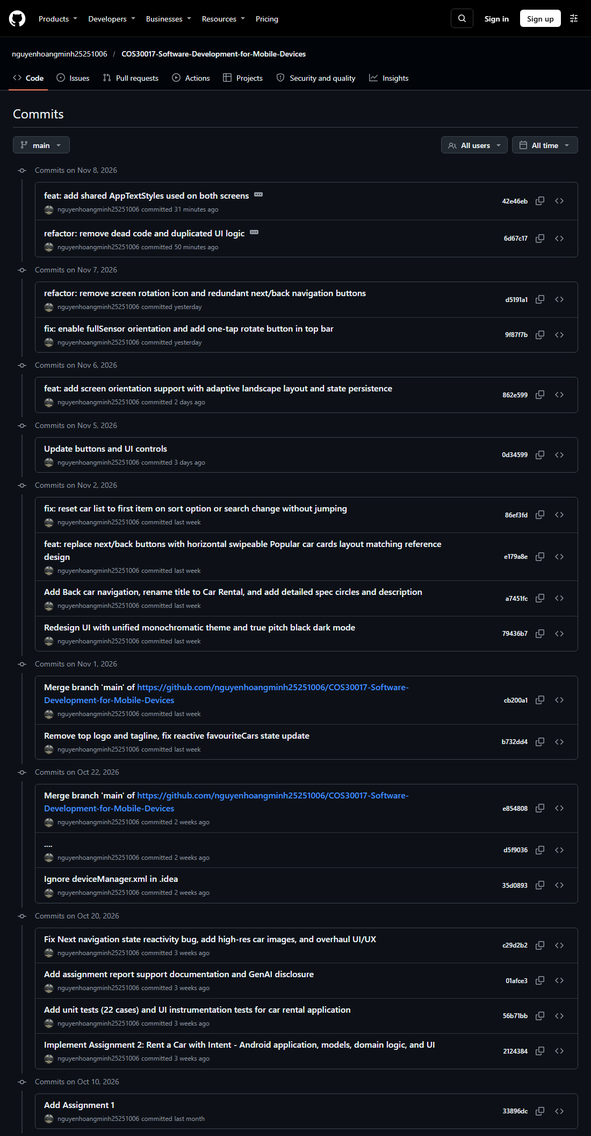
Figure 1. GitHub commit history for Assignment 2.

3 User Stories and Use Cases

3.1 User stories
User story 1: renting a vehicle. As a customer, I want to browse the available vehicles and rent one with my credit balance, so that I can pick a suitable car and complete a booking.
Acceptance criteria:
- The five vehicles can be browsed by swiping the Popular Cars row, and an "n / total" counter shows which car is in view.
- Each catalogue card shows the model, year, kilometres, star rating and daily cost.
- Rental length is chosen with a slider from 1 to 7 days, and the total cost updates as the slider moves.
- A booking is refused if the total exceeds 400 credits or the available balance.
- The user can confirm with "Confirm Booking", or cancel with "Cancel Booking" or the system Back button.
- After a successful booking the car leaves the catalogue, the credits are deducted and the car appears under "Active Rentals", where it can be returned for a full refund.
User story 2: finding and managing favourites. As a customer, I want to search, sort and save cars I like, so that I can quickly find vehicles that match my preferences.
Acceptance criteria:
- Search works on vehicle name and model through a text field.
- A heart icon on each card adds or removes a favourite, and favourites appear in their own Favourites row below the Popular Cars row.
- Sorting is available by rating (highest first), year (newest first) and daily cost (lowest first).
- A favourite stays visible after it has been rented.

3.2 Use case UC01: rent a vehicle
Actor | Customer
Precondition | The app is running and at least one vehicle is available.
Trigger | The customer taps "Rent" on a vehicle card.
Postcondition | The booking is recorded, credits are deducted and the vehicle is removed from the available list.
Main flow
- The customer browses the catalogue and taps "Rent".
- MainActivity starts RentalActivity with an explicit Intent carrying the Car (Parcelable), the credit balance, the dark mode state and the language.
- RentalActivity shows the vehicle summary and the booking controls.
- The customer moves the slider; the total cost updates live.
- The customer taps "Confirm Booking".
- CarRentalDomain.validateRental() checks that the car is free, the duration is 1 to 7 days, the total is at most 400 credits and the total does not exceed the balance.
- On success RentalActivity returns RESULT_OK with the car ID and number of days.
- MainActivity calls viewModel.processBookingResult(), which deducts credits and records the booking.
- A localised toast confirms the booking and the amount deducted.
Alternative flows
- Cancel or Back: RentalActivity returns RESULT_CANCELED, nothing changes and a toast says no credits were deducted.
- Validation failure: an error banner appears inside RentalActivity and no booking is submitted until the customer shortens the rental or cancels.
- Car already rented: a validation error is returned immediately.

3.3 Use case UC02: search and manage favourites
Actor | Customer
Precondition | The catalogue contains at least one vehicle.
Trigger | The customer types in the search field, changes the sort option or taps a heart icon.
Postcondition | The list shows the filtered and sorted result and the favourites row is up to date.
Main flow
- The customer types a keyword; CarRentalDomain.searchCars() filters name and model, ignoring case, on every keystroke.
- The catalogue shows only matching vehicles and returns to the first car.
- The customer taps the heart on a card; viewModel.toggleFavourite(carId) updates the favourites set.
- The Favourites row updates at once.
- The customer picks a sort option; CarRentalDomain.sortCars() returns a new sorted list and leaves the original data untouched.

3.4 Layout sketches: two options considered
Before building the screens I planned two low-fidelity layouts for the catalogue, each built from different widgets (Figure 2). The red labels name the widget used for each requirement.
Layout A: swipeable carousel (chosen). Everything the brief asks for sits on one scrolling screen: a credit widget at the top, an OutlinedTextField for search, FilterChips for sorting, a horizontal LazyRow of car cards with a heart, a star rating and a Rent button, then the Favourites row and Active Rentals. The next car is reached by swiping the row, and an "n / total" counter shows the position.
Layout B: one car at a time (alternative). A classic View-based screen: the balance and a SearchView sit in the app bar, sorting and dark mode are in the overflow menu, one large ImageView shows a single car with an XML RatingBar and a ToggleButton heart, and Previous and Next buttons step through the list. Favourites and rentals move to BottomNavigation tabs.
Choice. I chose Layout A. It keeps the balance, search, sort and favourites visible together, so the user never has to remember what is on another tab, and comparing two cars only needs a swipe. Layout B gives a bigger photo, but it hides sorting in a menu and needs one tap per car. Its Next button follows the wording of the brief; swiping the row meets the same need, and my tutor confirmed that swipe navigation is acceptable in place of a dedicated Next button. The high-fidelity version of Layout A was then drawn in Figma (Section 4.1).
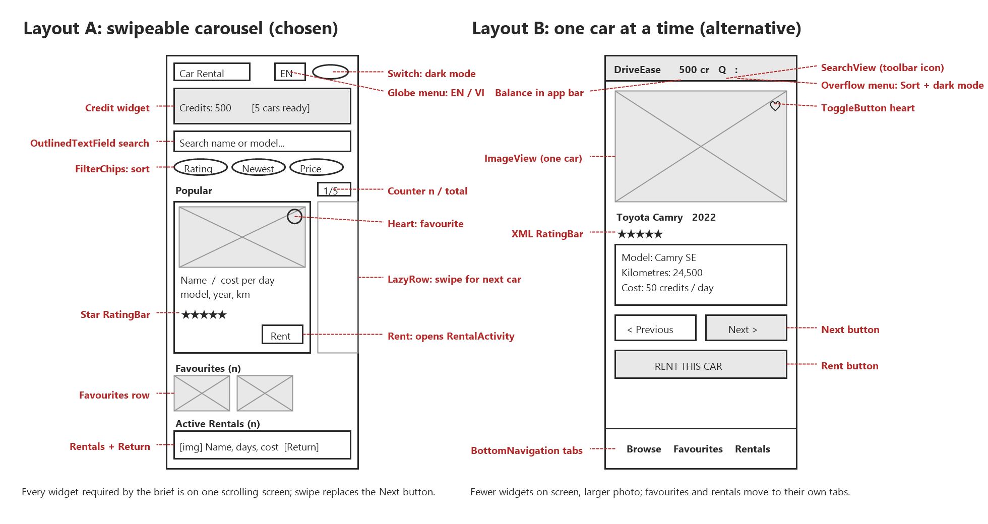
Figure 2. Low-fidelity sketches of two possible catalogue layouts, with the widgets labelled.

4 UI/UX Design

4.1 Design principles
The interface follows an editorial, automotive style, similar to the restrained look of car brand apps. I used Nielsen's (1994) usability heuristics as a checklist while designing, and Material Design 3 components (Android Developers, n.d.-e) so that controls behave the way Android users expect. The high-fidelity design of both screens was prepared in Figma: https://www.figma.com/design/54FhaO2u7iPpxt5mYDEJw6/Untitled?node-id=1-2 (Nguyen, 2026).
Principle | How it is applied in DriveEase
Visibility of system status (Nielsen, 1994) | The credit balance sits in a card directly below the top bar on every catalogue view. On the rental screen the total cost changes as the slider moves, so the user sees the effect of every choice.
Error prevention | All rules are checked by validateRental() before any state changes. The slider is limited to 1 to 7 days, so an out-of-range duration cannot be typed.
Help users recognise and recover from errors | A banner with a warning icon states the exact problem, for example the cost and the 400 credit limit, and stays on screen while the user adjusts the slider.
Consistency and standards | The same monochrome palette and Material 3 components appear on both screens. Colour has fixed jobs: amber for ratings, red for favourites, charcoal or white for the main action.
Feedback | Toasts confirm bookings, cancellations, returns and favouriting in the current language.
Minimalist design | A card shows only name, model, year, kilometres, rating and daily cost, and the rental screen repeats this summary next to the booking controls instead of adding further detail.
Accessibility | Text uses sp units so it scales with system font size, icon buttons carry content descriptions, and Compose icon buttons keep a 48dp minimum touch target. Text colours on both themes are far above the 4.5:1 contrast ratio required by WCAG 2.1 level AA (W3C, 2018): white on pure black is 21:1.

4.2 Catalogue screen (MainActivity)
The screen is laid out from top to bottom so that the most frequent actions are within thumb reach and the credit balance never leaves the screen. The numbers in the list match the markers in Figure 3.
- Top app bar: title, language menu (globe icon) and a light/dark Switch.
- Credits card: the available credits used for validation and the number of cars ready to rent.
- Search: an OutlinedTextField for live search, with a clear button once text has been typed.
- Sort: three FilterChips (Rating, Newest, Lowest price) for one-tap sorting.
- Popular Cars: a swipeable LazyRow of 280dp cards; each card shows the photo, name, daily cost, model, year, kilometres, star rating, a heart and a Rent button. Swiping the row to the left shows the next car.
- Position counter: an "n / total" badge that updates as the row is swiped, so the user always knows where they are in the list.
- Favourites and Active Rentals: a row of compact favourite cards (a rented favourite is marked "Currently Rented", and an empty row shows a short message), followed by one card per active booking with the days, total cost and a Return button.
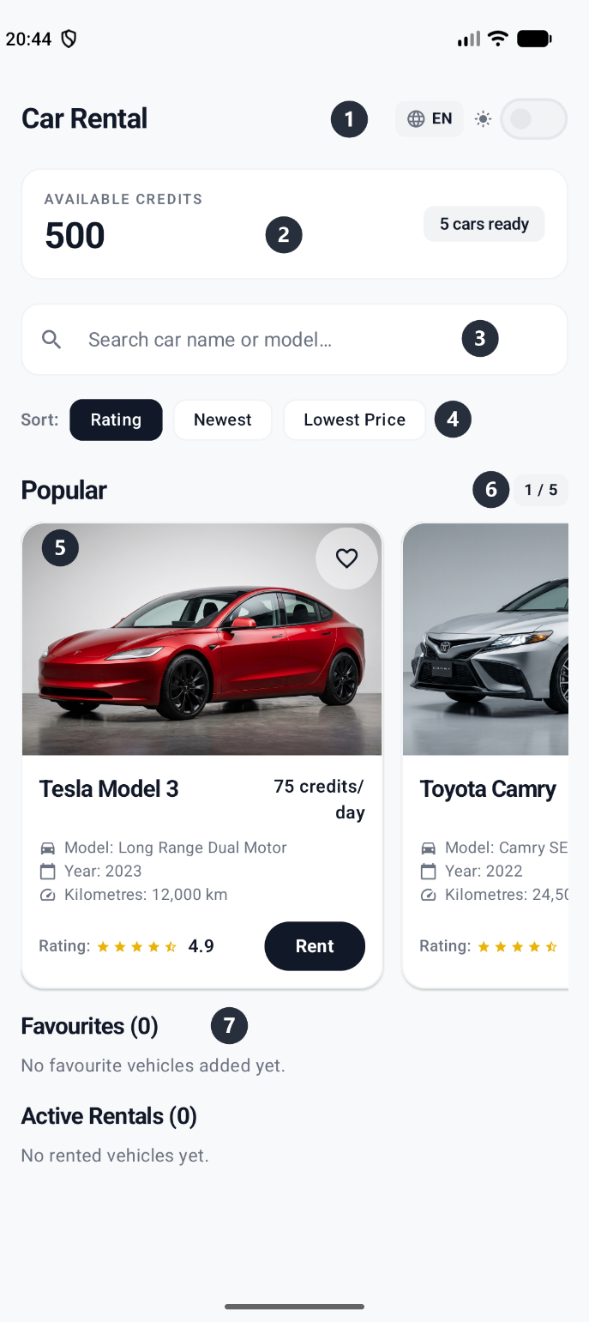
Figure 3. CatalogueScreen in light mode with annotated regions.
The widgets used on this screen are listed below. Two of them, the star rating bar and the switch, are not text widgets.
Widget | Purpose
TopAppBar | Title, language menu button and theme switch
Switch | Light and dark mode
IconButton (globe) and DropdownMenu | English and Vietnamese toggle
OutlinedTextField | Real-time search
FilterChip (three chips) | One-tap sort selection
LazyRow with Card | Popular Cars and Favourites rows
Image | Vehicle photo
StarRatingBar (custom composable) | Rating with half-star precision
IconButton (heart) | Favourite toggle on each card
Button | Rent and Return actions

4.3 Dark mode
The dark theme uses true black (#000000) for the background instead of the usual dark grey, because black pixels are switched off on OLED screens and save battery. Cards use #121214 so they still stand out from the background. The light theme uses an off-white background (#F8F9FA), white cards and deep charcoal (#111827) for primary actions. The selected mode is passed to RentalActivity so both screens always match.
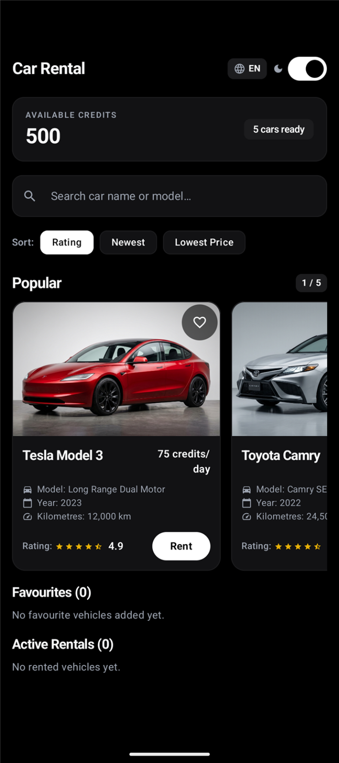
Figure 4. CatalogueScreen in dark mode.
Reusable styles. The brief asks for at least two styles used in more than one place. Colours come from the two Material 3 colour schemes in Theme.kt, so every element that reads MaterialTheme.colorScheme changes with the dark mode switch on both screens. Text is styled through three named TextStyle objects in ui/theme/Type.kt (AppTextStyles), and each one is used on both activities:
- SectionTitle (bold, 18sp): "Popular", "Favourites (n)" and "Active Rentals (n)" on the catalogue, and "Rental Duration" on the rental screen.
- BadgeLabel (semi-bold, 13sp): the "n cars ready" badge on the catalogue, and the year badge and day counter on the rental screen.
- Caption (12sp): the model, year and kilometre lines on every car card, and the slider limits and the balance and total labels on the rental screen.
The styles do not include colour, so the same style reads correctly in light and dark mode. Compose has no style attribute like XML, so a shared TextStyle is its equivalent of a <style> resource; an earlier styles.xml that no composable referenced was removed. Shared shapes follow the same idea: outlineBorder(), SectionTitle and OutlinedBadge in ui/components/CommonUi.kt replace about a dozen repeated border and badge definitions.

4.4 Search, sort and favourites
Search results update on each keystroke, so the user gets feedback immediately and does not need a search button. Sorting never changes the underlying data, so clearing the search or changing the sort always returns the full list.
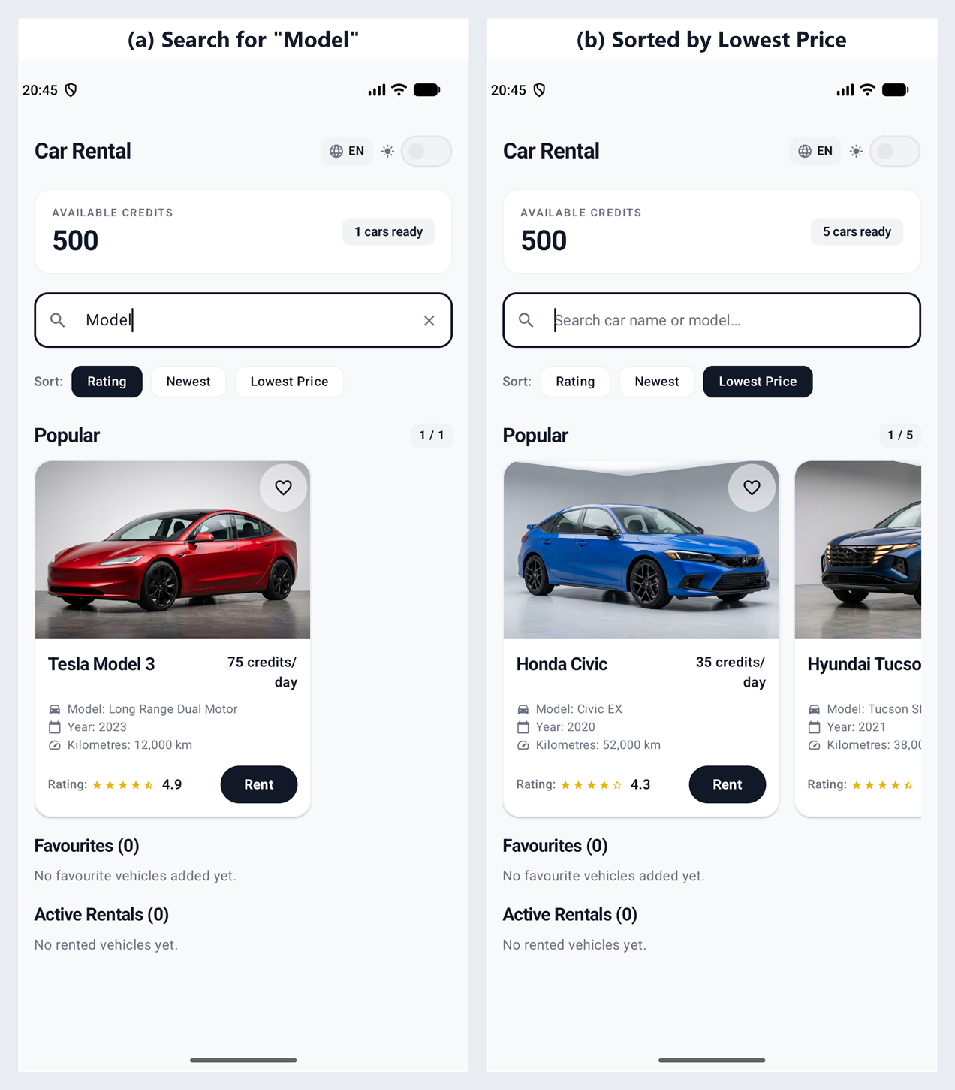
Figure 5. Search and sort results.
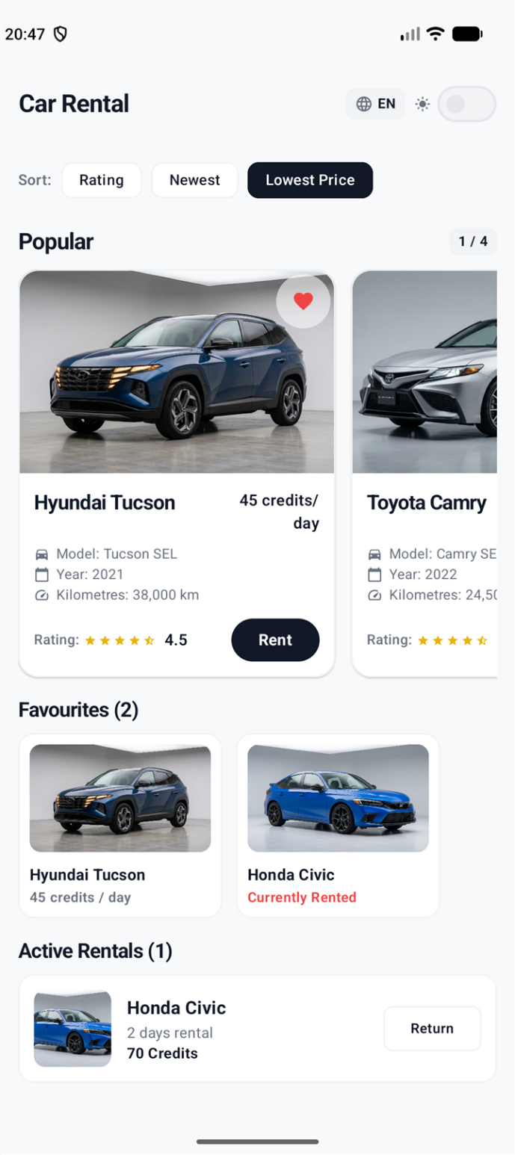
Figure 6. Favourites row, including a favourite that has been rented.

4.5 Rental screen (RentalActivity)
The rental form is a single scrolling column so that it fits any screen height: the vehicle image; name, model and year; a star rating; kilometres driven and daily cost; a duration card with the native Slider, a live day counter and the current balance and total cost; an error banner when validation fails; and two buttons side by side, "Cancel Booking" and "Confirm Booking".
The slider is a better fit than a number field on a phone: it needs no keyboard, it cannot produce an invalid number, and the cost updates while the finger is still moving (Android Developers, n.d.-g). The error banner is placed under the slider so the user can fix the problem without leaving the form.
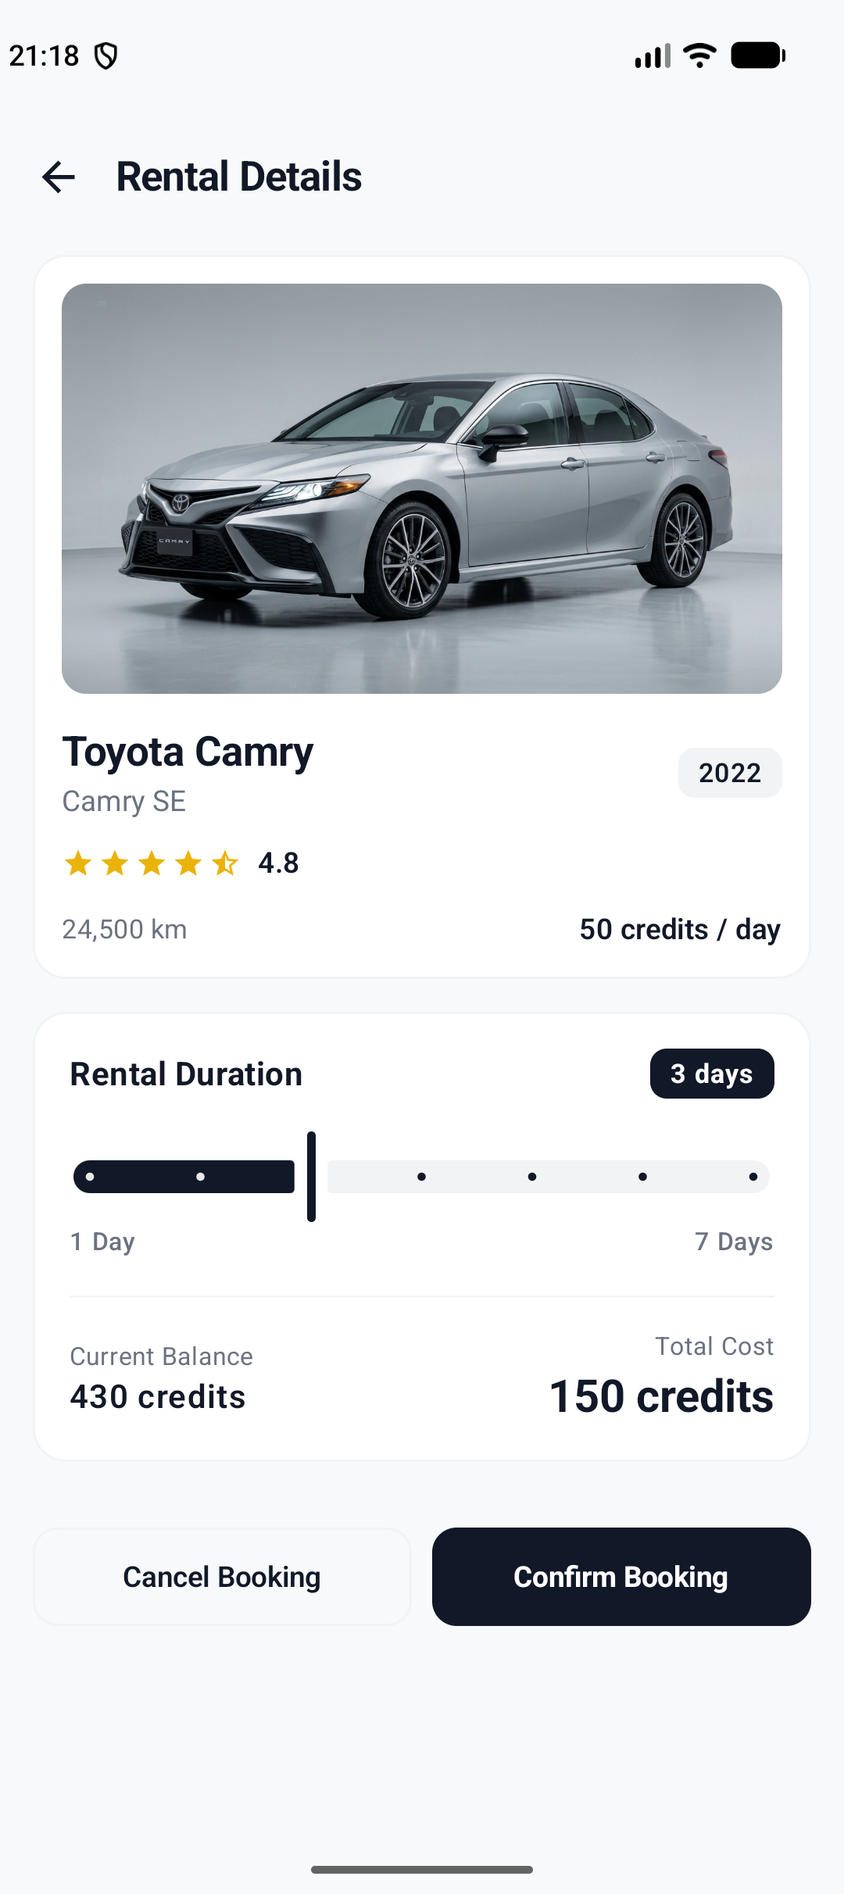
Figure 7. RentalScreen with slider and live total cost.
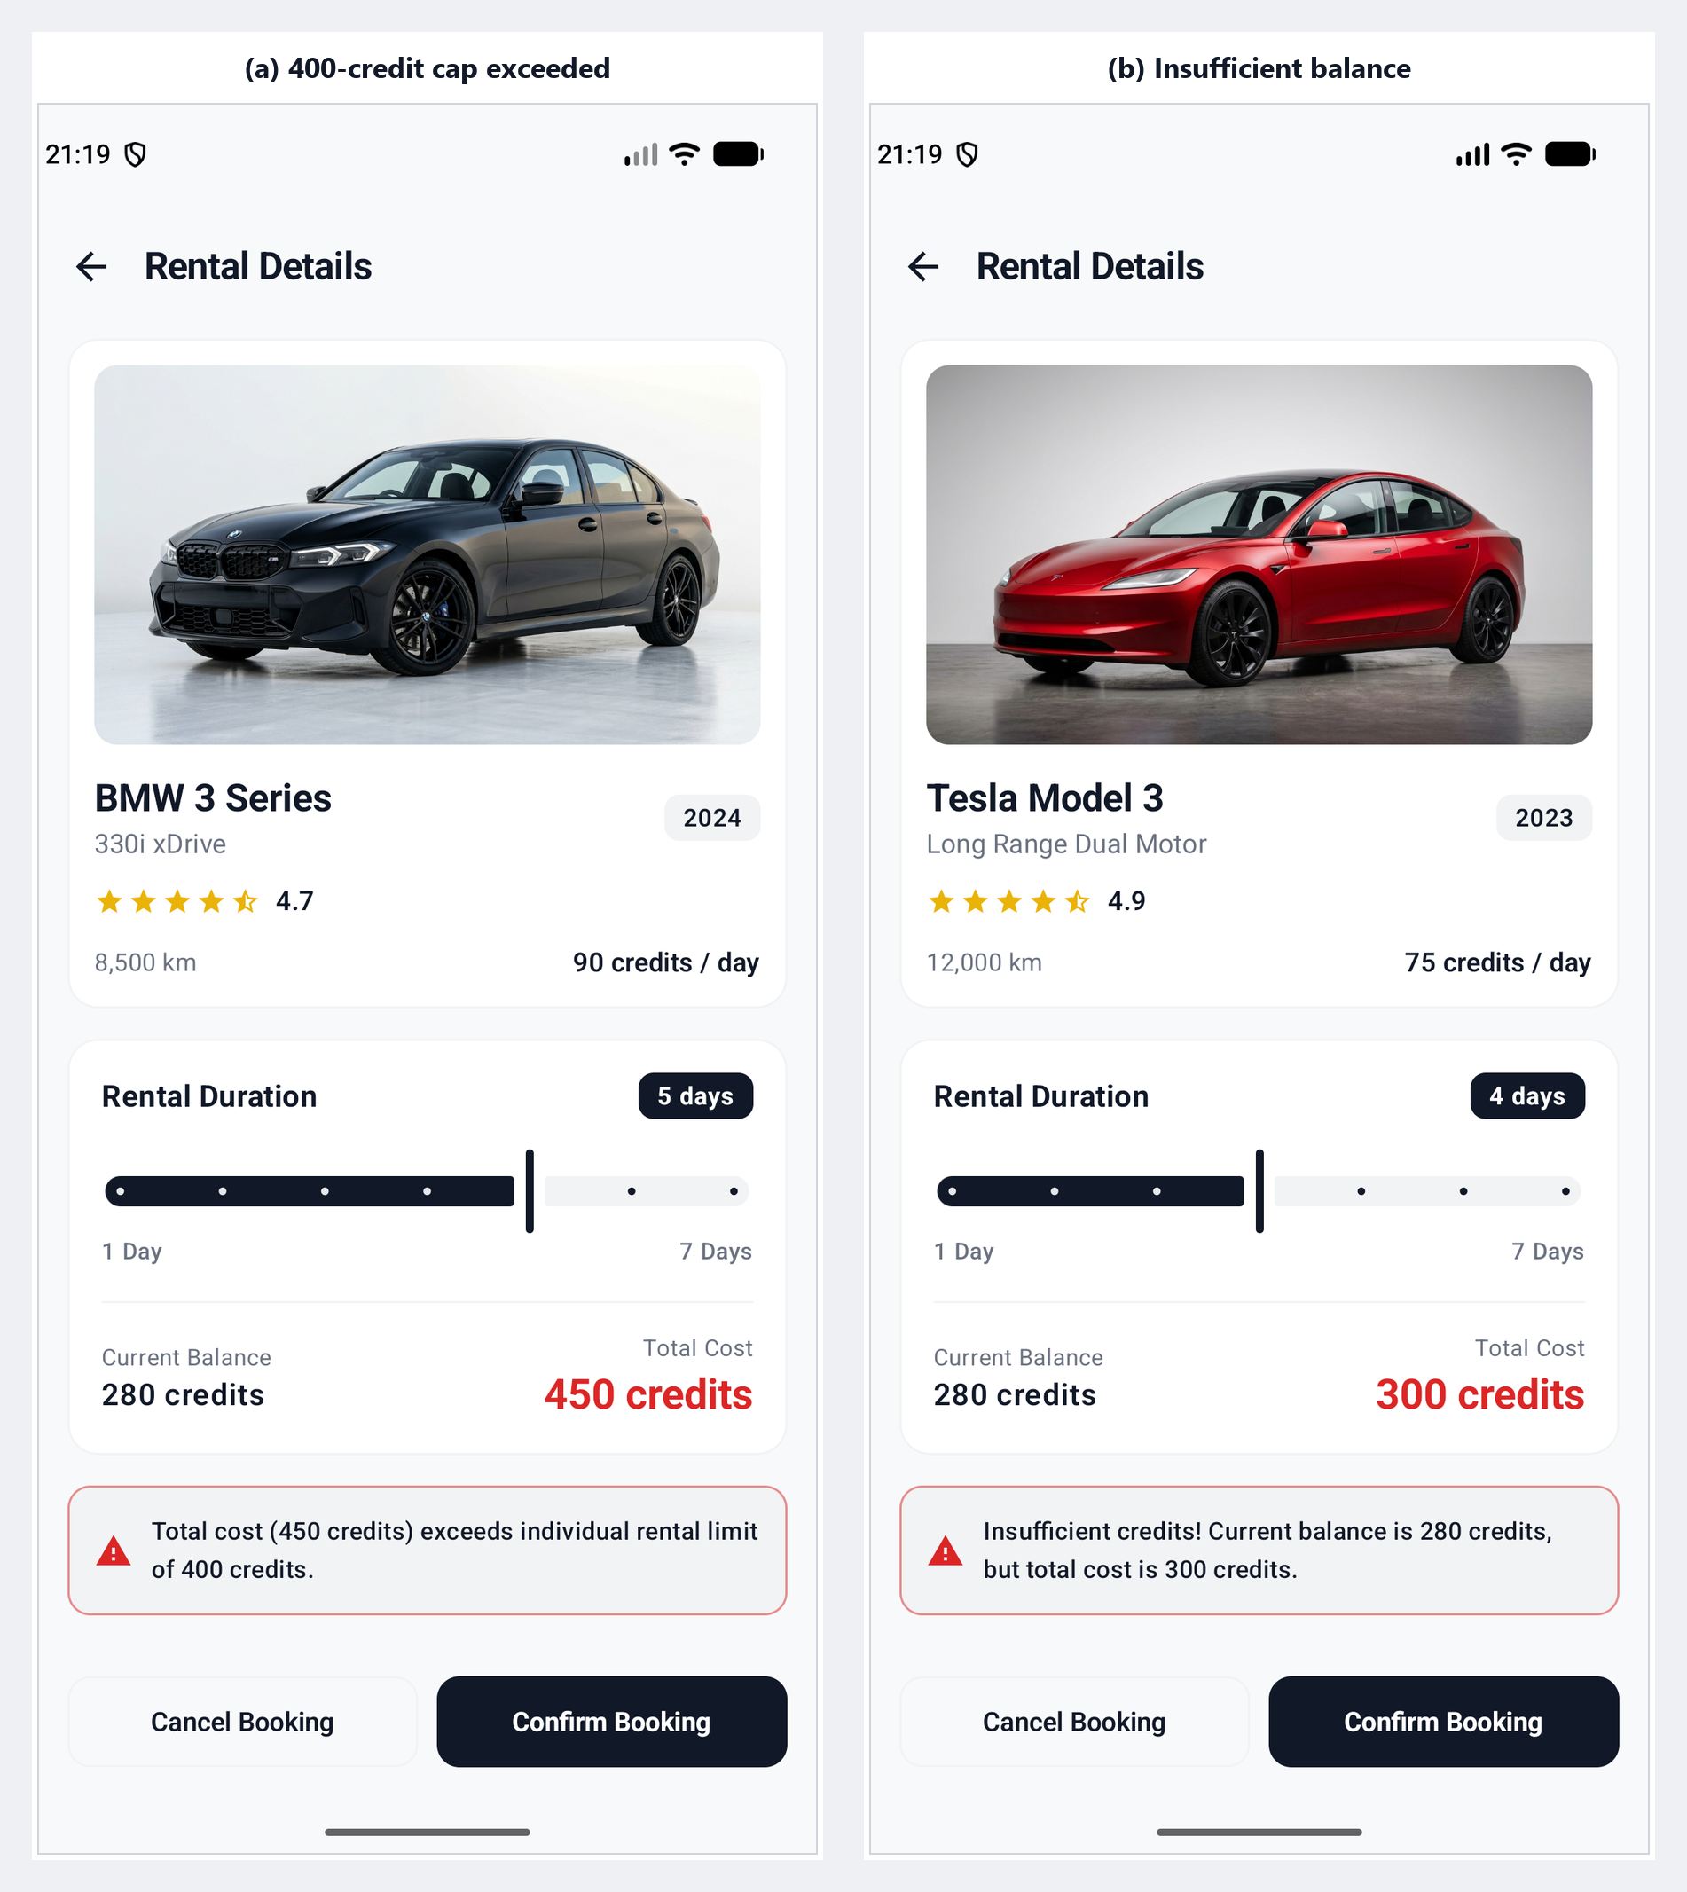
Figure 8. Validation error banners.

4.6 Designing for mobile constraints
- Screen size: one vehicle is the focus at a time; the rest are reached by swiping a horizontal row, which suits one-handed use. Secondary detail is moved to the rental screen instead of being squeezed onto the catalogue.
- Memory: LazyRow composes only the cards that are visible, and the five vehicles are held once in a canonical list. Search and sort create derived lists and do not copy images.
- Battery: true black dark mode, as described above.
- Lifecycle: the ViewModel and rememberSaveable keep the selected car, slider position, balance, favourites and bookings when the device rotates; Section 4.8 describes the adaptive landscape layout.
- Device range: minimum SDK 24 with a version check for the newer getParcelableExtra overload.

4.7 Bilingual interface
The globe button switches the whole interface, including toasts, between English and Vietnamese without restarting the Activity. The choice is carried to RentalActivity in the Intent so both screens use the same language.
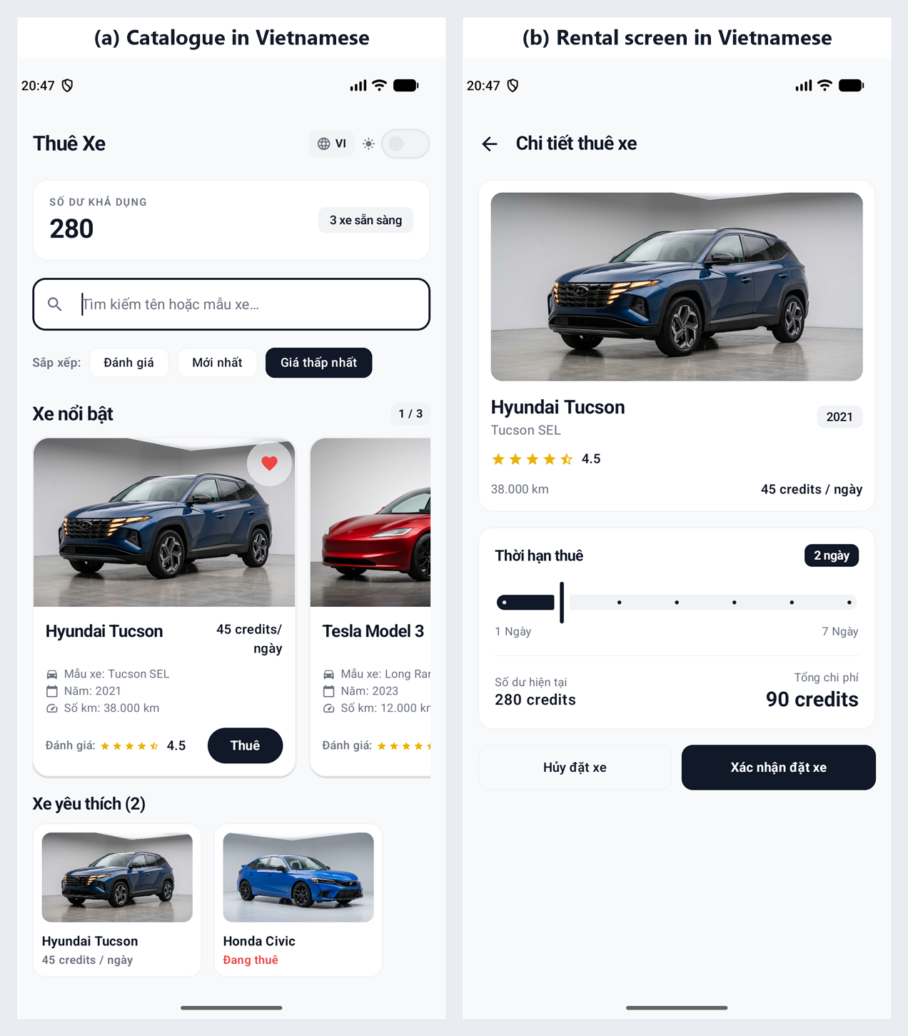
Figure 9. Vietnamese localisation on both screens.

4.8 Adaptive portrait and landscape layout
DriveEase does not lock the orientation. Each screen reads the current Configuration through LocalConfiguration and chooses a layout when it composes: portrait keeps the single-column flow described above, while landscape rearranges the same composables into columns. Both layouts share one state and one set of widgets, so there is no second screen to maintain.
On the catalogue screen the credits card and the search and sort controls share the top row, the Popular Cars row widens each card to 300dp, and Favourites and Active Rentals form a side-by-side dashboard (Figure 10). On the rental screen the vehicle summary fills the left column while the duration slider, cost breakdown and action buttons fill the right column, so the total cost stays visible while the slider moves (Figure 11).
Rotation recreates the Activity. The slider position, validation message and open language menu are kept with rememberSaveable, and the selected car index, credits, favourites and bookings live in the ViewModel and repository, which outlive the recreated Activity. The screenshots in Figure 10 were taken after a booking and a rotation, with the 3-day rental and the favourite still present.
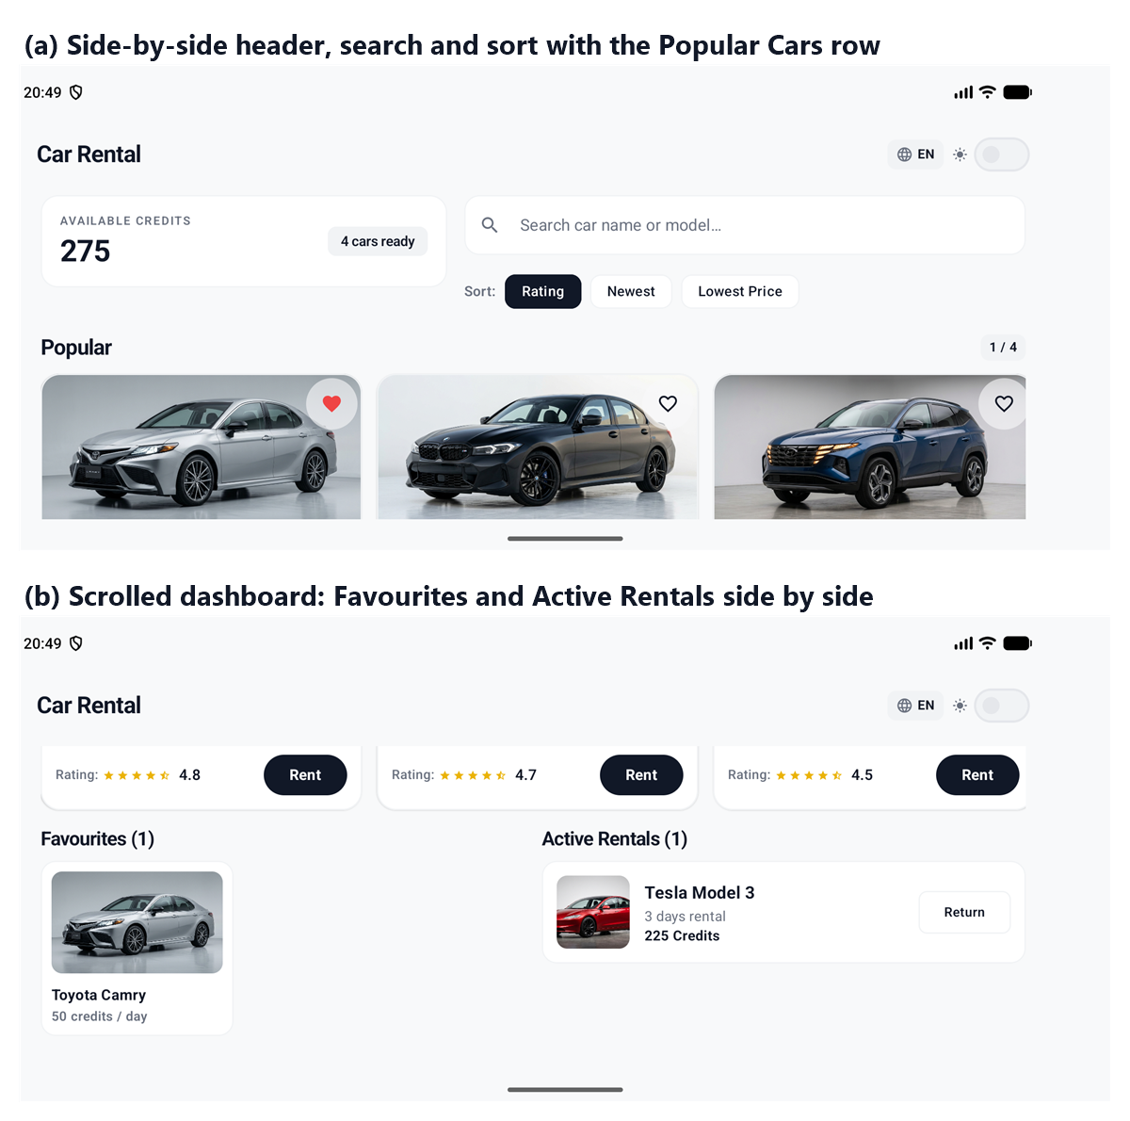
Figure 10. CatalogueScreen in landscape: (a) adaptive header and Popular Cars, (b) Favourites and Active Rentals side by side.
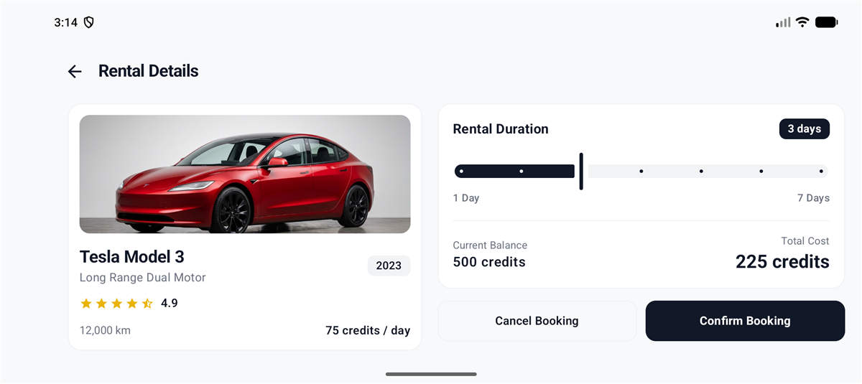
Figure 11. RentalScreen in landscape with the vehicle summary and booking controls in two columns.

5 System Architecture and Implementation

5.1 Architecture
The app uses five layers, each with one job. Dependencies point downwards, and only the UI knows about Compose.
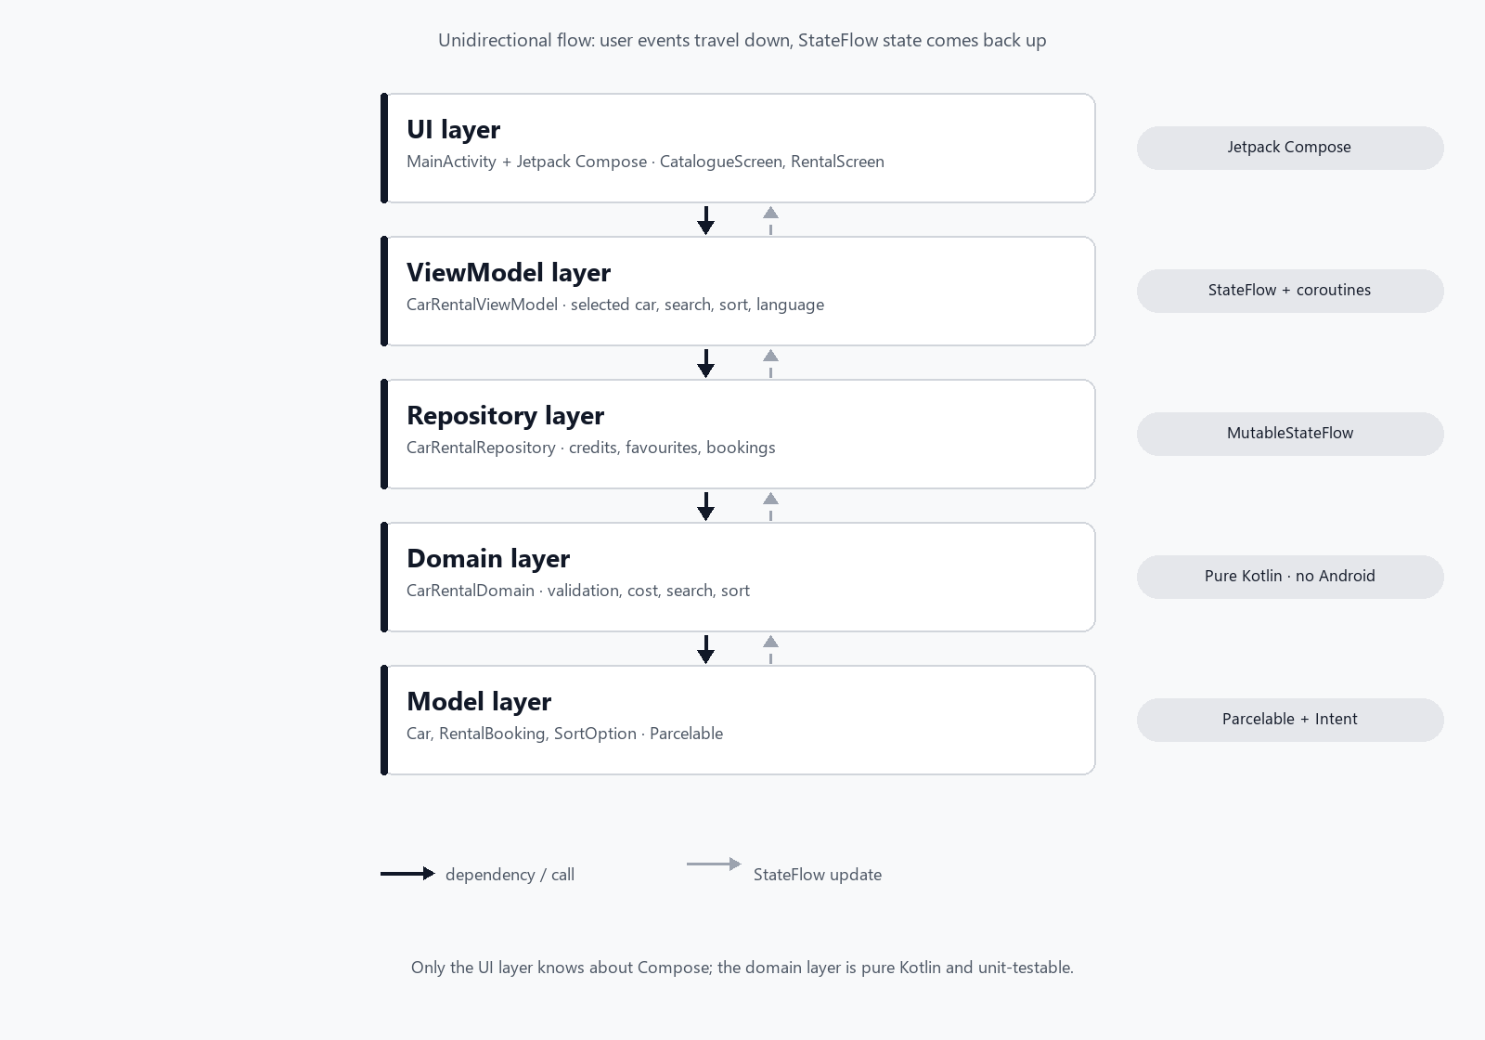
Figure 12. Layered architecture of DriveEase.
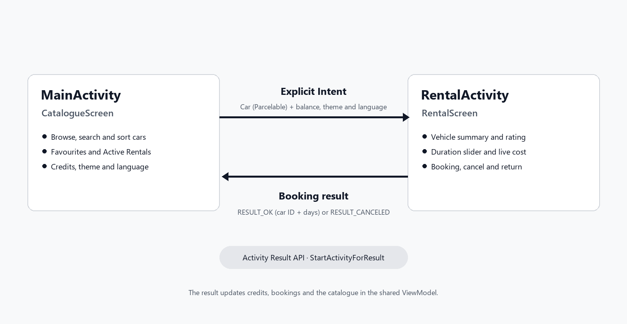
Figure 13. Navigation flow between the two activities.
MainActivity owns the ViewModel, launches RentalActivity with ActivityResultContracts.StartActivityForResult() (Android Developers, n.d.-a) and processes the returned result. RentalActivity receives the Car, validates the booking again with the same domain function, and returns the result.

5.2 Vehicle data model
Car is a Kotlin data class with 15 properties. Seven of them (engine, seats, colour, mileage, transmission, fuel type, description) have default values, so a car can be created with only the first eight. It implements Parcelable by hand (Android Developers, n.d.-f).
Property | Type | Meaning
id | String | Unique ID such as "car_001"
name, model | String | Brand name and model variant
year | Int | Manufacturing year
rating | Float | 1.0 to 5.0
kmsDriven | Int | Kilometres driven
dailyCost | Int | Credits per day
imageResId | Int | Drawable resource ID
engine, color, mileage, transmission, fuelType, description | String | Specification text
seats | Int | Number of seats
The five vehicles used in the app:
Vehicle | Model | Year | Rating | Daily cost | Fuel
Toyota Camry | Camry SE | 2022 | 4.8 | 50 | Gasoline
Tesla Model 3 | Long Range Dual Motor | 2023 | 4.9 | 75 | Electric
Hyundai Tucson | Tucson SEL | 2021 | 4.5 | 45 | Gasoline
BMW 3 Series | 330i xDrive | 2024 | 4.7 | 90 | Premium gasoline
Honda Civic | Civic EX | 2020 | 4.3 | 35 | Gasoline

5.3 State management
CarRentalRepository keeps one MutableStateFlow per piece of state. The original vehicle list is never changed; the list shown on screen is rebuilt from it whenever search, sort or bookings change.
State | Type | Description
_creditBalance | MutableStateFlow<Int> | Current credits, starting at 500
_favourites | MutableStateFlow<Set<String>> | IDs of favourite cars
_rentedBookings | MutableStateFlow<List<RentalBooking>> | Active rentals
_searchQuery, _sortOption | MutableStateFlow | Current search text and sort choice
_availableCars | MutableStateFlow<List<Car>> | Derived: filtered and sorted cars still available
_favouriteCars | MutableStateFlow<List<Car>> | Derived: cars whose IDs are favourites

5.4 Activity communication with Intents
When the user taps "Rent", MainActivity builds an explicit Intent for RentalActivity and starts it through a launcher registered with rememberLauncherForActivityResult (Android Developers, n.d.-b; n.d.-c). I used the Activity Result API instead of the older startActivityForResult() because that method is deprecated and does not fit Compose.
Components of the Intent. The Intent sent to RentalActivity uses only the parts it needs. Its component is set explicitly with RentalActivity::class.java, so Android does not resolve it against intent filters, and no action, category or data URI is set because the target is already known. The payload is in the extras, a Bundle of key-value pairs: EXTRA_CAR holds the Parcelable Car, and three primitive extras carry the balance, the theme and the language. The keys are constants in the companion object of RentalActivity, so the sender and the receiver cannot disagree on a spelling. The way back uses a second Intent: RentalActivity calls setResult() with a result code (RESULT_OK or RESULT_CANCELED) and a result Intent whose extras hold the car ID, the days and the total cost, and the callback registered with rememberLauncherForActivityResult receives both.
Sending (MainActivity)
val intent = Intent(this, RentalActivity::class.java).apply {
putExtra(RentalActivity.EXTRA_CAR, car) // Parcelable
putExtra(RentalActivity.EXTRA_CREDIT_BALANCE, viewModel.creditBalance.value)
putExtra(RentalActivity.EXTRA_IS_DARK_MODE, isDarkMode)
putExtra(RentalActivity.EXTRA_LANGUAGE, appLanguage)
}
rentalLauncher.launch(intent)
Receiving (RentalActivity)
val car = if (Build.VERSION.SDK_INT >= Build.VERSION_CODES.TIRAMISU) {
intent.getParcelableExtra(EXTRA_CAR, Car::class.java)
} else {
@Suppress("DEPRECATION") intent.getParcelableExtra(EXTRA_CAR)
}
val creditBalance = intent.getIntExtra(EXTRA_CREDIT_BALANCE, CarRentalDomain.INITIAL_CREDIT_BALANCE)
Returning the result (RentalActivity) and handling it (MainActivity)
// RentalActivity
setResult(RESULT_OK, Intent().apply {
putExtra(EXTRA_BOOKED_CAR_ID, car.id)
putExtra(EXTRA_RENTAL_DAYS, days)
putExtra(EXTRA_TOTAL_COST, totalCost)
})
finish()
// MainActivity
if (result.resultCode == RESULT_OK) viewModel.processBookingResult(bookedCarId, rentalDays)
else viewModel.notifyBookingCancelled()
Intent extra | Content
EXTRA_CAR | The full Car object (Parcelable)
EXTRA_CREDIT_BALANCE | Balance used for validation in RentalActivity
EXTRA_IS_DARK_MODE | Theme continuity
EXTRA_LANGUAGE | "en" or "vi"
EXTRA_BOOKED_CAR_ID, EXTRA_RENTAL_DAYS, EXTRA_TOTAL_COST | Result returned to MainActivity
Why Parcelable. Parcelable is Android's own mechanism for passing objects between components. It is faster than Java Serializable because it does not rely on reflection, and every field is written and read explicitly, so the format is visible in the code. The whole 15-property Car travels as one extra instead of 15 separate putExtra calls. On Android 13 and later the typed getParcelableExtra(key, Class) overload is used, with the older call as a fallback.

5.5 Rental rules and credit management
Each user starts with 500 credits. The cost of a rental is the daily cost multiplied by the number of days. validateRental() applies four rules in a fixed order and stops at the first failure.
fun validateRental(car: Car, rentalDays: Int, currentBalance: Int,
isAlreadyRented: Boolean = false): ValidationResult {
if (isAlreadyRented) return ValidationResult.Error("...", R.string.error_already_rented)
if (rentalDays !in MIN_RENTAL_DAYS..MAX_RENTAL_DAYS) return ValidationResult.Error("...", R.string.error_duration)
val totalCost = calculateTotalCost(car.dailyCost, rentalDays)
if (totalCost > MAX_RENTAL_COST) return ValidationResult.Error("...", ...) // 400
if (totalCost > currentBalance) return ValidationResult.Error("...", ...)
return ValidationResult.Success
}
- The car is not already rented.
- The duration is between 1 and 7 days.
- The total cost is at most 400 credits.
- The total cost is at most the available balance.
The 400 credit cap means the longest allowed rental depends on the car. It is the cap, not the 7 day limit, that restricts the two most expensive cars:
Vehicle | Daily cost | Cost for 7 days | Longest valid rental
Honda Civic | 35 | 245 | 7 days
Hyundai Tucson | 45 | 315 | 7 days
Toyota Camry | 50 | 350 | 7 days
Tesla Model 3 | 75 | 525 | 5 days (375 credits)
BMW 3 Series | 90 | 630 | 4 days (360 credits)
Cancellation. If the user presses Back or "Cancel Booking", RentalActivity calls setResult(RESULT_CANCELED) and finishes. MainActivity shows "Booking cancelled. No credits deducted." and nothing else changes.
Return. repository.returnRentedCar(carId) removes the booking from the rented list, puts the car back into the available list and refunds the full total cost.
Atomic update. processBooking() validates first and changes state only on success. A booking therefore deducts credits, records the booking and removes the car from the catalogue together, or does none of these.

5.6 Search and sorting
searchCars() checks, case-insensitively, whether the query is contained in the car name or model; an empty query returns every car. sortCars() returns a new list and never sorts the original in place. Each change to the search text or sort option resets the featured card to the first car, which fixed a bug described in Section 7.4.
Option | Kotlin operation | Order
RATING_DESC | sortedByDescending { it.rating } | Highest to lowest
YEAR_DESC | sortedByDescending { it.year } | Newest to oldest
COST_ASC | sortedBy { it.dailyCost } | Lowest to highest
The full pipeline is: canonical list, then remove rented cars, then search, then sort, then publish as availableCars.

5.7 Favourites
Favourites are stored as a set of car IDs. They are independent of availability: getFavouriteCars() looks cars up in the canonical list, not in the available list, so a rented car stays in the Favourites row.

5.8 Theme and language across activities
RentalActivity is a separate Activity with its own lifecycle, so it cannot observe MainActivity's ViewModel. The dark mode flag and language code are therefore passed in the Intent and applied once when it starts. MyApplicationTheme(darkTheme) picks between a light and a dark Material 3 colour scheme. A custom AppLocaleProvider creates a Context for the chosen language and supplies it through LocalContext, which is how the Vietnamese strings in res/values-vi/strings.xml are used without recreating the Activity.

5.9 Code structure and Kotlin features
The project follows the standard Android layout and separates packages by responsibility (the full tree is in Appendix A): model, domain, data, ui, ui/components and ui/theme. Kotlin features used to keep the code short and safe:
- Data classes with default and named arguments for Car and RentalBooking.
- An object (CarRentalDomain) with named constants for the limits (MIN_RENTAL_DAYS, MAX_RENTAL_DAYS, MAX_RENTAL_COST, INITIAL_CREDIT_BALANCE) instead of magic numbers.
- A result type with Success and Error cases, so callers must handle both.
- An enum for SortOption and immutable collection operations (filter, sortedBy) for derived lists.
- Null safety and the Elvis operator when reading Intent extras and Parcel values.
- StateFlow with collectAsState() so the UI recomposes automatically (Android Developers, n.d.-h).

6 Functionality and Technical Implementation

6.1 Requirements checklist
Requirement | Implementation | Test
Browse five vehicles | Popular Cars LazyRow: swipe to the next car, with an "n / total" counter | TC01 to TC03
Open second Activity with an explicit Intent | "Rent" button starts RentalActivity | TC04
Transfer vehicle data with Parcelable | Car (15 properties) as EXTRA_CAR | TC05
Rental duration with a non-text widget | Material 3 Slider, 1 to 7 days, live cost | TC06
Rating with a non-text widget | Custom StarRatingBar (full, half, empty stars) | TC01
Credit rules (500 start, 400 cap, balance check) | CarRentalDomain.validateRental() | TC06, TC09, TC10, UT-01 to UT-08
Confirm or cancel a booking | RESULT_OK or RESULT_CANCELED to MainActivity | TC06 to TC08
Favourites | Heart toggle and Favourites row | TC12, TC13, TC23, UT-18
Search and sort | searchCars() and sortCars() | TC14 to TC19, UT-09 to UT-13
Additional: dark mode | Switch and Material 3 colour schemes | TC20
Additional: English and Vietnamese | AppLocaleProvider and string resources | TC21
Additional: return a rented car | "Return" button and refund | TC22, UT-19

6.2 Browsing
The Popular Cars row shows one car in full and the edge of the next, which hints that the row scrolls. Swiping moves to the next or previous car and the "n / total" counter updates with it, so the row covers the Next requirement of the brief without a separate button; my tutor confirmed that this swipe navigation is acceptable. The visible index is written back to the ViewModel through snapshotFlow, so the same car is shown after a rotation, and changing the sort or the search text recreates the list state so the row starts again from the first car. Tapping a card or its Rent button opens the rental screen.

6.3 Rental validation and feedback
Validation happens in RentalActivity before anything is returned. A failure becomes an inline banner rather than a toast, because a toast disappears after a few seconds while the user still needs the message in front of them as they move the slider. Toasts are used for events that are finished: booking confirmed, cancelled or returned.
Event | Feedback (English)
Booking successful | "Booking successful! {cost} credits deducted for {days} day(s)."
Booking cancelled | "Booking cancelled. No credits deducted."
Car returned | "{Car name} returned to catalogue. Credits refunded!"
Over 400 credits or insufficient balance | Inline error banner on the rental screen
Toast text is built with a LocalizedToastMessage (a string resource ID plus format arguments) and resolved in the Activity, so it follows the selected language even when the message starts in the ViewModel.
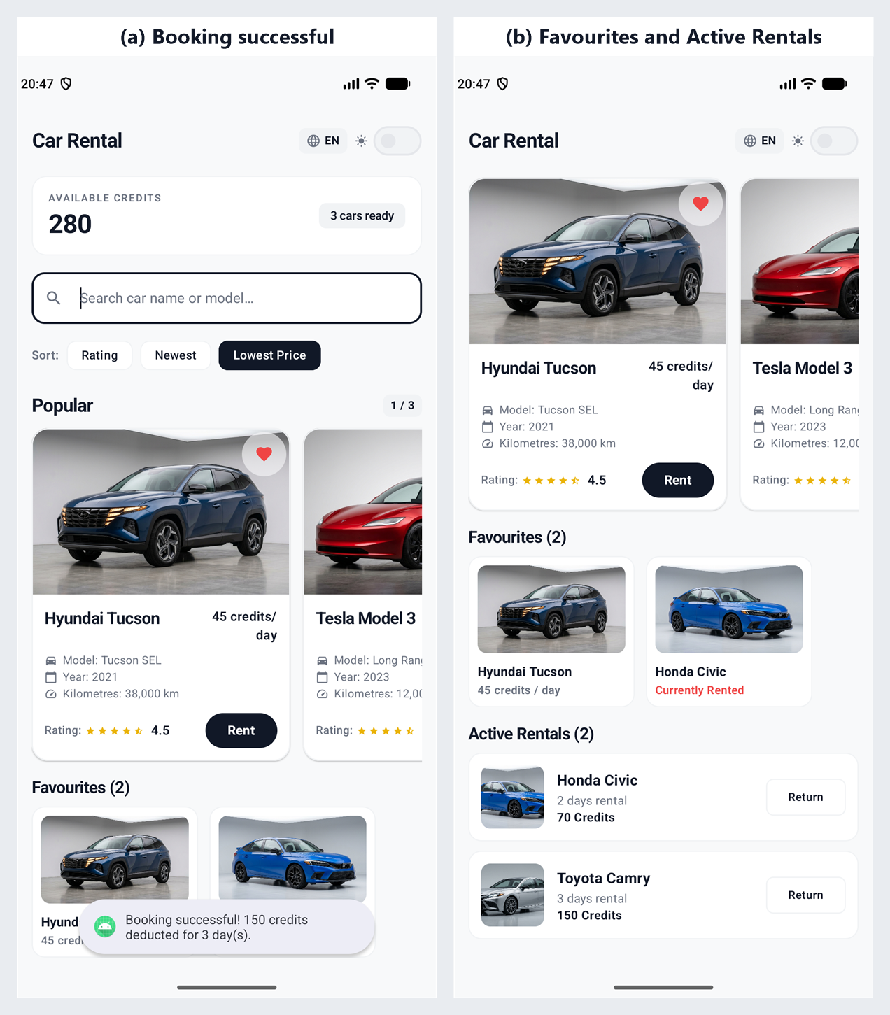
Figure 14. Booking successful toast and "Active Rentals" section.
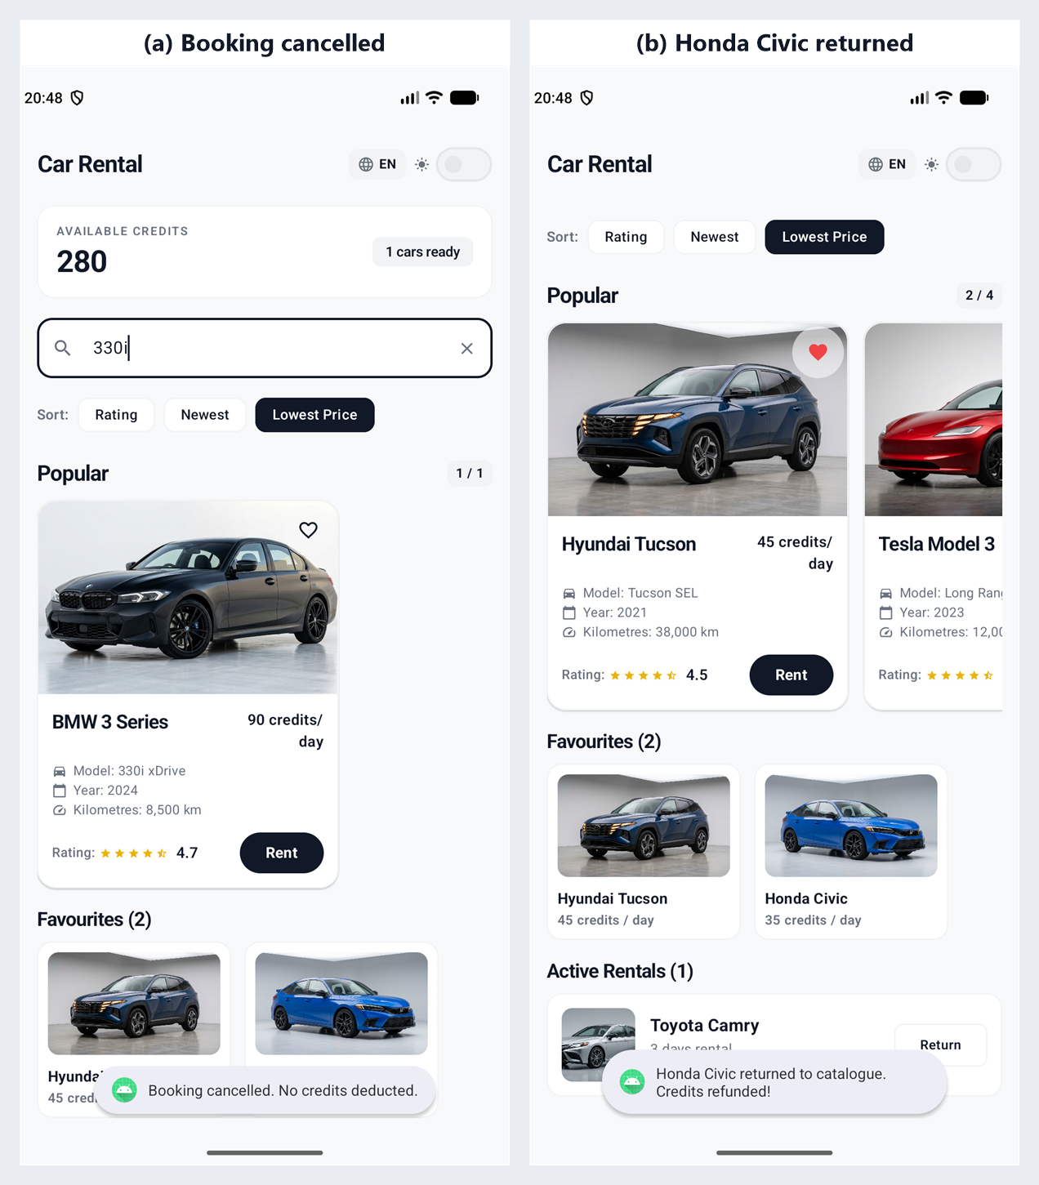
Figure 15. Booking cancelled toast and car returned toast.

6.4 Non-text widgets
Widget | Used for | Reason
StarRatingBar (custom, Material icons Star, StarHalf, StarOutline) | Showing the rating on cards and the rental screen | Shows 1 to 5 stars with half-star precision; replaces the XML RatingBar, which is not available in Compose
Slider | Choosing 1 to 7 days | Touch-friendly, cannot give an invalid value, gives live cost feedback
Switch | Light and dark mode | Clear two-state control
FilterChip | One-tap sort selection | Faster than opening a menu for each sort choice

7 Testing and Debugging

7.1 Strategy
Testing was done at three levels. Pure unit tests check the rules and state transitions on the JVM, with no emulator. Compose UI tests (3 cases in CarRentalUITest) check that the app launches, filters the list and toggles favourites on a device. Manual functional testing on the emulator then walks through each user story, including both languages and both themes. For the unit tests I used boundary value analysis: for each limit, one case on the boundary and one just outside it (for example 400 credits passes and 450 fails; 7 days passes and 8 fails).

7.2 Functional test cases (manual)
ID | Test | Action | Expected result | Actual result | Status
TC01 | Launch | Open the app | Five vehicles; balance 500 | Five vehicles; badge shows 500 | Pass
TC02 | Next vehicle | Swipe the Popular row to the left | Next vehicle shown | Next card and counter update (1 / 5 to 2 / 5) | Pass
TC03 | Previous vehicle | Swipe the Popular row to the right | Previous vehicle shown | Previous card and counter update | Pass
TC04 | Open rental screen | Tap "Rent" | RentalActivity opens for that car | Correct car displayed | Pass
TC05 | Parcelable transfer | Select BMW 3 Series, tap Rent | BMW 3 Series opens | Name, model, year and cost correct | Pass
TC06 | Valid booking | Camry, 3 days, Confirm | 150 credits deducted; car removed | Balance 350; Camry under Active Rentals | Pass
TC07 | Cancel button | Tap "Cancel Booking" | No change | Balance unchanged; car available | Pass
TC08 | Cancel with Back | Press system Back | No change | Balance unchanged; car available | Pass
TC09 | 400 credit cap | BMW, 5 days (450) | Booking blocked | Banner: exceeds 400 credit limit | Pass
TC10 | Insufficient balance | Reduce balance with rentals, rent again | Booking blocked | Banner: insufficient credit balance | Pass
TC11 | Duplicate booking | Look for a rented car in the catalogue | Not rentable again | Rented car not in available list | Pass
TC12 | Add favourite | Tap heart | Appears in Favourites row | Heart filled; row appears | Pass
TC13 | Remove favourite | Tap heart again | Removed from row | Heart outline; row shows the empty message | Pass
TC14 | Search by name | Type "Tesla" | Only Tesla Model 3 | Only Tesla shown | Pass
TC15 | Search by model | Type "330i" | Only BMW 3 Series | Only BMW shown | Pass
TC16 | Clear search | Delete the text | All vehicles | Full catalogue back | Pass
TC17 | Sort by rating | Rating, highest first | Tesla (4.9) first | Ordered by rating | Pass
TC18 | Sort by year | Year, newest first | BMW (2024) first | Ordered by year | Pass
TC19 | Sort by cost | Cost, lowest first | Honda (35) first | Ordered by cost | Pass
TC20 | Dark mode | Turn on the Switch, open Rent | Both screens dark | Black background on both | Pass
TC21 | Language | Tap globe icon | Vietnamese UI | Labels, buttons and toasts in Vietnamese | Pass
TC22 | Return car | Tap "Return" | Car back; credits refunded | Car in catalogue; balance restored | Pass
TC23 | Favourite then rent | Favourite a car, rent it | Stays in Favourites row | Visible in row and in Active Rentals | Pass

7.3 Automated unit tests
There are 27 JUnit tests: 13 in CarRentalDomainTest, 8 in CarRentalRepositoryTest and 6 in CarRentalViewModelTest. The two newest ViewModel tests check that the selected car index is stored in the ViewModel and clamped to the available range, which is what keeps the current card stable across a rotation. They run with ./gradlew app:testDebugUnitTest.
ID | Area | What is checked | Result
UT-01 | Cost | 1-day and 7-day cost at 50 credits per day | Pass
UT-02 | Duration | 1 and 7 days are accepted | Pass
UT-03 | Duration | 0 and 8 days are rejected | Pass
UT-04 | 400 cap | Exactly 400 (80 x 5) is accepted | Pass
UT-05 | 400 cap | 450 (90 x 5) is rejected | Pass
UT-06 | Balance | 200 credit rental with balance 250 is accepted | Pass
UT-07 | Balance | 200 credit rental with balance 150 is rejected | Pass
UT-08 | Duplicate | Already rented car returns an error | Pass
UT-09 | Sort | RATING_DESC order: Tesla, Toyota, BMW, Hyundai, Honda | Pass
UT-10 | Sort | YEAR_DESC order: BMW, Tesla, Toyota, Hyundai, Honda | Pass
UT-11 | Sort | COST_ASC order: Honda, Hyundai, Toyota, Tesla, BMW | Pass
UT-12 | Immutability | Sorting does not change the original list | Pass
UT-13 | Search | Case-insensitive name and model filter; empty query returns all | Pass
UT-14 | Repository | Initial state: balance 500, 5 available, 0 rented | Pass
UT-15 | Repository | Camry for 3 days: balance 350, 4 available | Pass
UT-16 | Repository | Second booking of the same car fails; balance unchanged | Pass
UT-17 | Repository | Cancelled booking leaves credits unchanged | Pass
UT-18 | Repository | Rented car stays in favourites | Pass
UT-19 | Repository | Returned car restores credits and availability | Pass
UT-20 | Repository | nextCar() moves index from 0 to 1 | Pass
UT-21 | Repository | resetState() restores 500 credits, 5 available, 0 rented | Pass
UT-22 | ViewModel | Default language is English | Pass
UT-23 | ViewModel | Switching to Vietnamese updates the language | Pass
UT-24 | ViewModel | Toggling the language alternates between English and Vietnamese | Pass
UT-25 | ViewModel | Invalid language code is ignored | Pass
UT-26 | ViewModel | Setting the current car index updates the selected car | Pass
UT-27 | ViewModel | Current car index is clamped to the available range | Pass
Result: 27 of 27 tests passed, 0 failures.
These results were checked again on 8 November after the final review (Section 8.6): the 27 unit tests and the 3 Compose UI tests passed on the Pixel 9 emulator, and the manual cases in Section 7.2 were repeated. Figures 1, 3 to 6, 9, 10, 14 and 15 were retaken on that day.
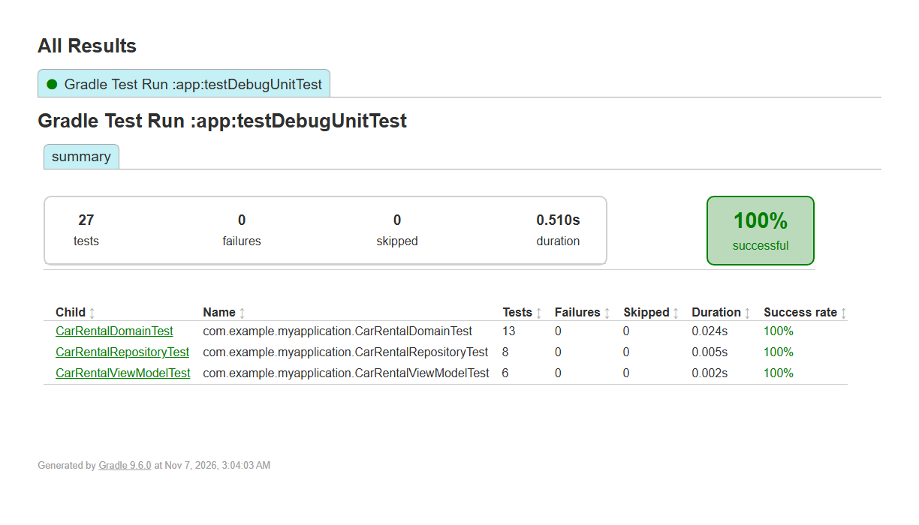
Figure 16. Unit test results in the Gradle test report.

7.4 Debugging
Five defects were found while testing, each traced to a root cause and re-tested after the fix.
Symptom | Root cause | Fix | Re-test
Catalogue did not refresh after a booking or a return | availableCars was not re-emitted after _rentedBookings changed | Call updateComputedCars() at the end of processBooking() and returnRentedCar() | TC06, TC22
Next button jumped to a wrong card after a search | The selected index was not reset when the filtered list became shorter | Reset the index to 0 in setSearchQuery() and setSortOption() | Searched "Tesla" (1 result), pressed Next: stayed at 0
Favourites row did not update when a heart was tapped | _favouriteCars was not recomputed after _favourites changed | Call updateFavouriteCars() inside toggleFavourite() | TC12, TC13
RentalActivity crashed on API below 33 | getParcelableExtra(key, Class) exists only from API 33 | Version check with the deprecated overload as fallback | Ran on API 24 emulator: no crash
Toasts stayed in English in Vietnamese mode | The ViewModel built the message from hard-coded English text | LocalizedToastMessage(resId, formatArgs), resolved in the Activity | TC21

8 Challenges, Explorations and Takeaways

8.1 Passing a 15-property object between activities
Challenge. The Car model has 15 properties. Sending each as a separate extra would make the Intent long and easy to break, because the sender and receiver must agree on every key and type.
Exploration. I compared Serializable and Parcelable. Serializable needs no extra code but uses reflection, which is slower on Android. I also considered the @Parcelize annotation, but the kotlin-parcelize plugin was not set up in the Gradle version catalog, and I preferred not to change the build configuration for one class. I wrote Parcelable by hand.
Outcome and takeaway. The first working version passed every field correctly. The part that needed care was the order: createFromParcel() must read fields in exactly the order writeToParcel() wrote them, because a mismatch gives wrong values with no error. Later I also found the API 33 crash (Section 7.4), which taught me that code that works on my emulator may fail on older Android versions.

8.2 Keeping credits, bookings and the catalogue consistent
Challenge. One booking changes four things at once: the balance, the bookings list, the available cars and the selected index. If any one is skipped, the app contradicts itself, for example credits taken while the car is still shown as available.
Exploration. Keeping variables inside the Activity would lose them on rotation and could not be shared. A companion object would work but is fragile and hard to test. A ViewModel with StateFlow survives configuration changes, is reactive and can be tested without a device.
Outcome and takeaway. I made processBooking() the only place that changes booking state. It validates through CarRentalDomain first and changes state only on success. The two bugs where the catalogue and the favourites row did not refresh (Section 7.4) had the same cause: derived state was not recomputed after a source changed. Separating validation from state change made both parts easy to test, and it is the main design lesson of this project.

8.3 Search and sort without losing the original list
Challenge. Search and sort must change what is shown, but clearing the search has to bring back the full list in the original order.
Exploration. Sorting the displayed list directly is simple, but it loses the original. I kept one canonical list and derived the displayed list from it each time using Kotlin's non-mutating functions.
Outcome and takeaway. A test (UT-12) confirms that sorting leaves the original unchanged. Using sortedBy and filter instead of in-place sorting removed a whole class of bugs. The search bug in Section 7.4 came from a different cause: the selected index was not reset when the list got shorter, so the derived list was correct but the index pointed past its end.

8.4 Theme consistency across two activities
Challenge. Both activities must show the same theme, but RentalActivity cannot observe MainActivity's ViewModel.
Exploration. Following the system theme would remove the user's control. An application-scoped ViewModel would work but ties the two activities together more than necessary. Passing a Boolean in the Intent is simple and fits how Android activities already communicate.
Outcome and takeaway. RentalActivity is short-lived, so reading the theme once at startup is enough. I learned that not every piece of state needs to be reactive; the right scope for state depends on how long its consumer lives.

8.5 Changing language at runtime
Challenge. Android normally picks the language at launch from device settings. I wanted a button that changes language immediately and also translates toasts.
Exploration. AppCompatDelegate.setApplicationLocales() needs API 33 or the AppCompat library, and this project is a pure Compose project with minimum SDK 24. Instead I built AppLocaleProvider, which wraps the content in a Context created with createConfigurationContext() and exposes it through LocalContext. The first version still showed English toasts, because the ViewModel created the text itself. Moving to LocalizedToastMessage fixed it.
Outcome and takeaway. This showed me how CompositionLocal passes values through a UI tree without adding a parameter to every function, and that user-visible text should be resolved as late as possible, close to the UI, not in business logic.

8.6 Redesign after using the first version
The first catalogue (20 October) showed one car at a time with Next and Back buttons. After using it, I found that comparing cars meant tapping repeatedly and that it felt dated next to the premium look I wanted. On 2 November I redesigned it: monochrome theme, pure black dark mode, larger photo-led cards and a swipeable Popular Cars row, still with arrows and Back/Next Car buttons (79436b7, a7451fc, e179a8e); the fix 86ef3fd followed straight away when the new row exposed the index bug. On 7 November, after the landscape work, I used the screen again in both orientations and found that the arrows and buttons only repeated what a swipe already did while taking space under every card. I removed them together with the rotate button (d5191a1), kept the "n / total" counter so the position stays visible, and checked with my tutor that swiping meets the Next requirement of the brief. The lesson was that a design should be judged by using it, not by whether the code works, and that removing a control can improve a screen as much as adding one.

8.7 Overall reflection and future work
This assignment taught me to think about how features affect each other, not only how each screen works. Moving from XML layouts to Compose was hard at first, particularly state hoisting and when recomposition happens, but the result is shorter and reacts to state automatically.
Changes since Assignment 1. Assignment 1 (the gymnastics scoring app) was a single Activity with XML layouts. It kept three state values in a Bundle through onSaveInstanceState and followed the device language. Its main lesson, keep the state small and draw the screen from it, carried straight over, but I changed three things on purpose. State moved into a ViewModel with StateFlow, because one booking touches four values and a Bundle would have needed each of them saved and restored by hand. The UI moved to Compose, so the screen is redrawn from state automatically instead of through my own updateUI() function. The language became an in-app setting, so a user can switch without changing the phone. One habit did not change enough: I still pushed commits in large batches (Section 2.4), and in the next assignment I will commit each step when it is finished.
Three improvements would come next. First, persistence: bookings, balance, favourites and language are lost when the app closes, so Room and DataStore would be the production choice. Second, more UI tests: the three Compose tests only cover launch, search and favourites, and a complete rental flow and theme switch should be tested too. Third, a drawn icon set and tablet layout, since the layout was only tested on phone-size screens.

8.8 Use of generative AI
Generative AI was used as a development and learning aid, not as a replacement for my own work. I used Google Antigravity with Gemini 3.8 Flash during October and November 2026 to explain Android and Compose concepts, check my understanding of the assignment logic, and draft parts of the Kotlin code and test structure. I also used an AI image-generation tool to create the five vehicle images shown in the catalogue and on the rental screen. Every output was reviewed, edited, built and tested before it was kept.
The logic came first. When I was unsure about a mechanism, I asked for an explanation before asking for code: why the selected car index must live in the ViewModel so it survives a rotation, how a 15-property Car travels through an Intent as a Parcelable, and why filtering and sorting should return a new list instead of changing the repository list. Code suggestions were treated as drafts; I read each change, ran ./gradlew app:testDebugUnitTest and the app on the emulator, fixed the defects listed in Section 7.4 and re-tested the affected flows.
- Learning and planning: explanations of the Activity lifecycle, Intents, StateFlow and configuration changes, which I re-explained in my own words and then applied in the app.
- Code and debugging: draft Kotlin and Compose functions, Gradle fixes and JUnit test structure, checked by building the project, running the 27 unit tests and repeating the manual test cases.
- Vehicle images: five AI-generated car images used on the cards and rental screen; I checked the model, body style and colour, cropped each image to the card ratio and stored it as a drawable resource.
- Report support: outline, test plan and wording suggestions, rewritten in my own words and checked against the app and the cited sources.
The vehicle images are illustrative assets, not manufacturer press photographs, and the specification data in Car.kt is written by hand and does not depend on them. All AI-assisted code, text and images were reviewed and validated by me. I understand and can explain the submitted code, can reproduce the test results, and accept responsibility for the final report. The prompts and outputs are listed in Appendix E.

9 Conclusion
DriveEase meets the assignment brief with two activities that exchange data through explicit Intents, a 15-property Parcelable Car, a Slider and a custom star rating as non-text widgets, and rental rules that enforce a 500 credit start, a 400 credit cap and a balance check. Search, sort, favourites, dark mode, bilingual support and returning a rented car are added on top, and each has test cases.
The layered structure (model, domain, repository, ViewModel, UI) kept the rules testable: 27 unit tests pass, and the manual test table covers every user-facing feature. The main limitation is that data is only in memory. The main lesson is that consistent state, and a clear owner for each piece of it, matters more than any single screen.

10 References
Android Developers. (n.d.-a). Getting a result from an activity. https://developer.android.com/training/basics/intents/result
Android Developers. (n.d.-b). Intents and intent filters. https://developer.android.com/guide/components/intents-filters
Android Developers. (n.d.-c). Jetpack Compose overview. https://developer.android.com/compose
Android Developers. (n.d.-d). Kotlin coroutines on Android. https://developer.android.com/kotlin/coroutines
Android Developers. (n.d.-e). Material Design 3 for Compose. https://m3.material.io/develop/android/jetpack-compose
Android Developers. (n.d.-f). Parcelable interface. https://developer.android.com/reference/android/os/Parcelable
Android Developers. (n.d.-g). Slider (Material 3). https://developer.android.com/reference/kotlin/androidx/compose/material3/package-summary#Slider
Android Developers. (n.d.-h). StateFlow and SharedFlow. https://developer.android.com/kotlin/flow/stateflow-and-sharedflow
Android Developers. (n.d.-i). ViewModel overview. https://developer.android.com/topic/libraries/architecture/viewmodel
JetBrains. (n.d.). Collection ordering. Kotlin Documentation. https://kotlinlang.org/docs/collection-ordering.html
Nguyen, H. M. (2026). DriveEase: car rental app interface design [Figma file]. https://www.figma.com/design/54FhaO2u7iPpxt5mYDEJw6/Untitled?node-id=1-2
Nielsen, J. (1994). 10 usability heuristics for user interface design. Nielsen Norman Group. https://www.nngroup.com/articles/ten-usability-heuristics/
World Wide Web Consortium. (2018). Web content accessibility guidelines (WCAG) 2.1. https://www.w3.org/TR/WCAG21/

Appendices

Appendix A: Project structure
app/src/main/java/com/example/myapplication/
MainActivity.kt Catalogue host, launches rentals, handles result
RentalActivity.kt Rental host, validates, returns result
data/CarRentalRepository.kt StateFlow state, atomic bookings
domain/CarRentalDomain.kt Validation, cost, search, sort (pure Kotlin)
model/Car.kt Parcelable vehicle
model/RentalBooking.kt Parcelable booking
model/SortOption.kt Sort enum
ui/CarRentalViewModel.kt UI state and actions
ui/components/StarRatingBar.kt Custom rating widget
ui/components/AppLocaleProvider.kt Runtime locale override
ui/components/CommonUi.kt Shared border, section title and badge
ui/theme/Color.kt, Theme.kt, Type.kt (colours, theme and AppTextStyles)
app/src/test/.../CarRentalDomainTest.kt 13 tests
app/src/test/.../CarRentalRepositoryTest.kt 8 tests
app/src/test/.../CarRentalViewModelTest.kt 6 tests
app/src/androidTest/.../CarRentalUITest.kt 3 Compose UI tests
app/src/main/res/values/strings.xml, values-vi/strings.xml

Appendix B: Running the tests
./gradlew app:testDebugUnitTest
Expected result: BUILD SUCCESSFUL, 27 tests completed, 0 failed. A screenshot of this run is Figure 16 in Section 7.3.

Appendix C: Colour palette
Mode | Background | Surface (cards) | Primary accent
Light | #F8F9FA off-white | #FFFFFF | #111827 deep charcoal
Dark | #000000 true black | #121214 | #FFFFFF

Appendix D: Key design decisions
- Compose instead of XML: collectAsState() recomposes automatically when a StateFlow changes, so no adapter refresh calls are needed.
- Activity Result API instead of startActivityForResult(): the old method is deprecated and does not work with Compose.
- Domain logic separate from the repository: CarRentalDomain has no Android dependencies, so its 13 tests run on the JVM.
- RentalBooking is Parcelable: it is only used inside MainActivity now, but this allows passing bookings between screens later.
- True black dark theme: better battery life on OLED screens and stronger contrast with the cards.

Appendix E: Generative AI prompts and outputs
E.1 Gemini 3.8 Flash in Google Antigravity (October to November 2026). The full chat history was not exported, so each entry gives my request in summary and what the tool returned.
- Request: inspect the project and Gradle files and plan Assignment 2 against the rubric. Output: an implementation plan (IMPLEMENTATION_PLAN.md) with milestones mapped to the requirements, and a check of the Kotlin, Compose and Material 3 versions in the version catalog.
- Request: create the Car model as a Parcelable, the rental rules (1 to 7 days, 400 credit cap, balance check), search and sort, and an in-memory repository with StateFlow. Output: draft Car, CarRentalDomain and CarRentalRepository code. I rewrote Car to implement Parcelable by hand because the kotlin-parcelize plugin was not set up (Section 8.1).
- Request: build MainActivity and RentalActivity in Compose, pass the car with an explicit Intent and return the booking with the Activity Result API. Output: draft CatalogueScreen and RentalScreen, the StarRatingBar, the Slider and the error banner, which I then tested and debugged (Section 7.4).
- Request: write boundary unit tests and Compose UI tests for launch, search and favourites. Output: draft JUnit and Compose tests and TEST_PLAN.md; I added the ViewModel tests later.
- Request: explain why the selected car index must live in the ViewModel to survive rotation, and why sorting should return a new list. Output: explanations of configuration changes and of non-mutating collection functions, applied in Sections 4.8 and 5.6.
- Request (image tool): studio photos of a silver Toyota Camry, a red Tesla Model 3, a blue Hyundai Tucson, a black BMW 3 Series and a blue Honda Civic. Output: five images, which I cropped and stored as drawable resources.
- Request: an outline for the report and a test plan. Output: REPORT_OUTLINE.md and TEST_PLAN.md, which I rewrote in my own words.

